**LAB #01**

**“OVERVIEW OF TENSORFLOW AND ITS OPERATIONS”**

**OBJECTIVE:**

• Understand the basics of deep learning and its applications.

• Set up the Python environment for deep learning.

• Perform basic operations using TensorFlow and Scikit-learn.

**“LAB TASK”**

**1.** Create a TensorFlow tensor with random float values. Calculate the sum, mean, and maximum of the tensor. **Hint:** Use tf.reduce_sum(), tf.reduce_mean(), tf.reduce_max().

Create a 3D TensorFlow tensor. Access and print a specific element, a 2D slice, and a 1D slice. **Hint:** Use standard Python indexing and slicing syntax)

* **CODE (1):**

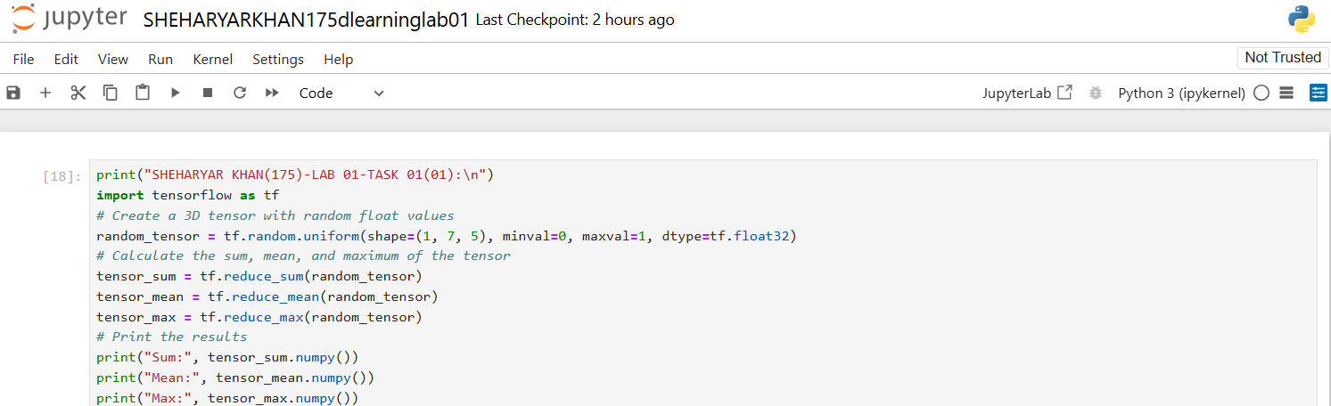

* **OUTPUT(1):**

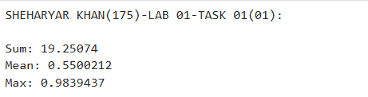

* **CODE (2):**

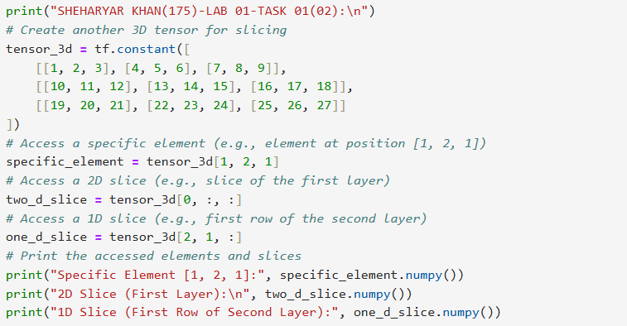

* **OUTPUT(2):**

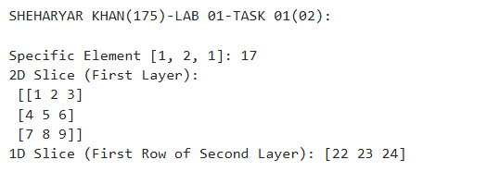

**2.** Create a TensorFlow function called tensor operations that takes two tensors as input and performs the following arithmetic operations:

• Addition (tensor1 + tensor2)

• Subtraction (tensor1 - tensor2)

• Multiplication (tensor1 * tensor2)

• Division (tensor1 / tensor2)

The function should return the results of these operations as a dictionary with the following keys:

• "addition"

• "subtraction"

• "multiplication"

• "division" etc

Test your function with the following tensors:

tensor1 = [10, 20, 30]

tensor2 = [5, 10, 15].

* **CODE:**

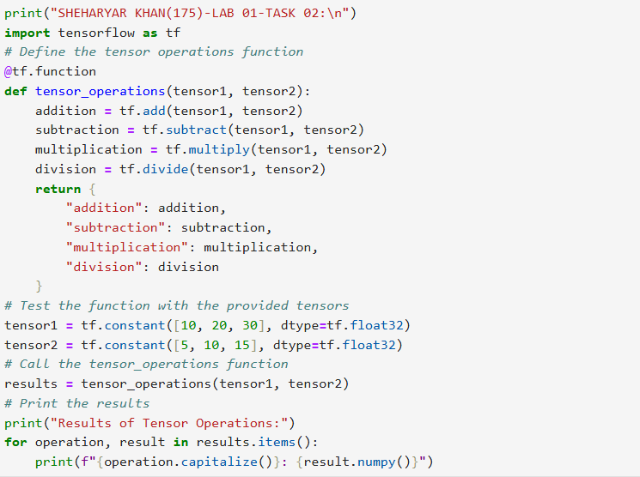

* **OUTPUT:**

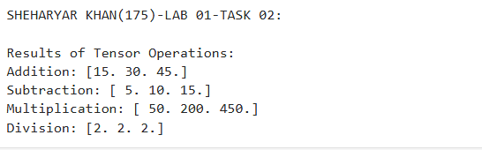

**3. (1):** Create a NumPy array with random float values. Sort the array in ascending and descending order. **Hint:** Use np.sort() and array slicing.

**(2):** Create a 2x2 NumPy matrix. Calculate its transpose and inverse.

**Hint:** Use np.transpose() and np.linalg.inv().

**(3):** Create a 2D NumPy array. Calculate the sum of each row, the mean of each column, and the standard deviation of the entire array.

* **CODE (1):**

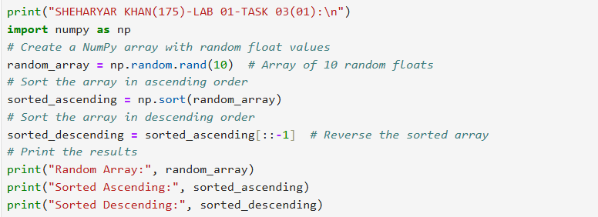

* **OUTPUT(1):**

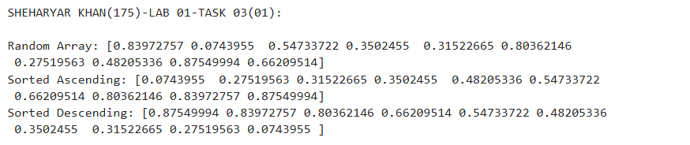

* **CODE (2):**

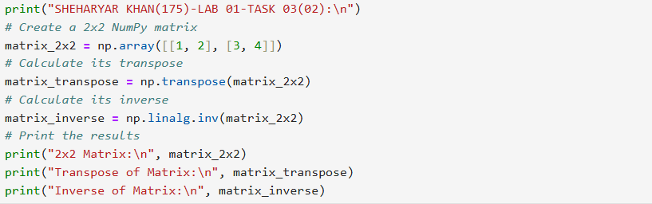

* **OUTPUT(2):**

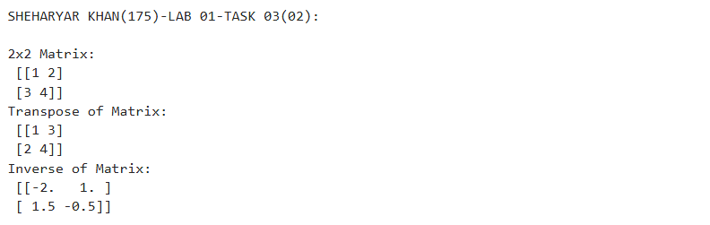

* **CODE (3):**

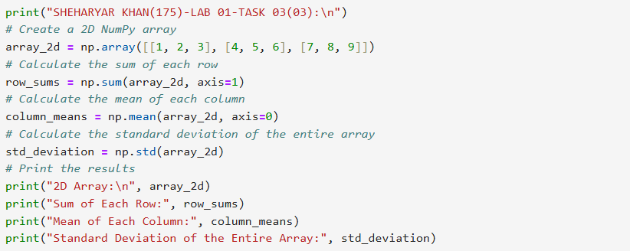

* **OUTPUT(3):**

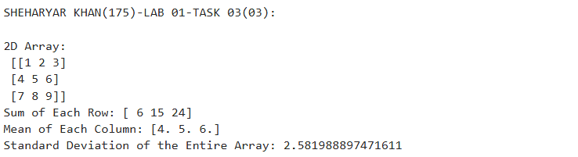

**“UPLOADING ON ACCOUNTS”**

* **KAGGLE:**
* **GITHUB:**